**Advanced User Interface 2015-2016**

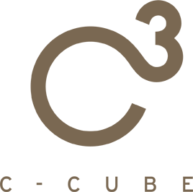

*The Killer wears Prada  
Find out the Fashion Killer!*



Final Presentation

**ABSTRACT**

The idea of our project is the implementation of a game based on a simple treasure hunt located in a fashion Shop. The goal of this game is to find out the outfit of a killer thanks to the clues given by some items present in the game which correspond to real clothes in the shop. The interaction between consumer and game is managed using a Kinect v2.

With our project we would like to address the needs of the shop owner (attract more consumers, increase sales, new items discovery) in a funny and simple way that also allows consumer to be entertained while shopping.

Presented By **C-cube TEAM**

The C-CUBE Team

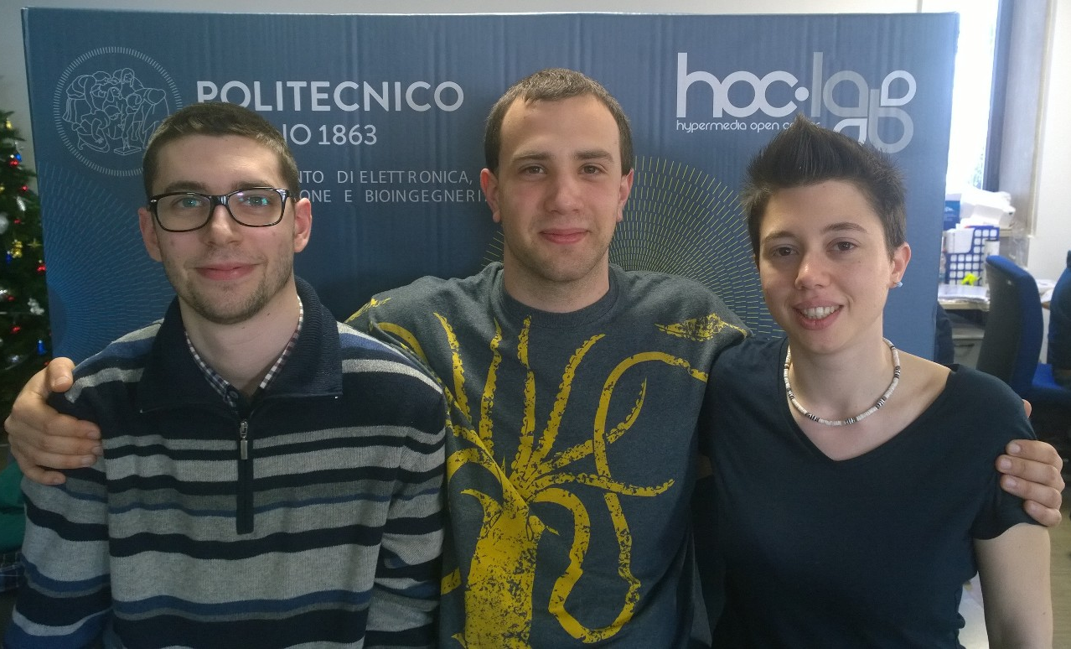

Monica Cecere

[monica.cecere@mail.polimi.it](mailto:monica.cecere@mail.polimi.it)

3773079682

Federico Maria Ceruti

[federicomaria.ceruti@mail.polimi.it](mailto:federicomaria.ceruti@mail.polimi.it)

Andrea Luigi Edoardo Caielli

[andrea.caielli@mail.polimi.it](mailto:andrea.caielli@mail.polimi.it)

Table of Contents

**Introduction** 5

**User Requirements** 6

**Stakeholder vs Need/Goal table** 6

**Stakeholders** 6

**Needs & Goals** 6

**Requirements** 7

**Scenarios** 8

**Scenario 1: First Time** 8

**Scenario 2: Parallel game** 11

**Scenario 3: Winning** 14

**Scenario 4: Registration** 15

**Demo Scenario** 16

**Differences between prototype and real solution** 18

**Game Logics** 19

**Game concepts** 19

**Game rules and mechanics** 20

**Population** 20

**Design and Graphical Choices** 22

**In-game windows appearance** 22

**Buttons** 23

**Position of the Buttons** 23

**Colour-changing door light** 23

**Gesture** 24

**Popup and animation** 24

**Implementation** 25

**Database** 25

**Database interface** 26

**Classes** 26

**Helpers** 28

**Controllers** 31

**Graphical Interface** 35

**UserControls** 35

**Feasibility study** 37

**Technical Analysis** 37

**Hardware** 37

**Workstation constraint** 37

**Software** 37

**Database** 38

**Timetable** 38

**Business Analysis** 39

**Profits** 39

**Costs** 39

**Risk Analysis** 41

**Conclusion** 42

**Main issues** 42

**Further Works** 42

**Why Choose US** 43

# **Introduction**

The idea of our project is the implementation a “find the clue” game based in a fashion Shop. The goal of this game is to find out how a killer was dressed thanks to the clues given by all the items present in each game’s room. Each item correspond to a real cloth in the shop. By collecting real clothes in the Shop you get them in the game inventory and then you can combine them, accordingly to the clues, create and submit the identikit.

The interaction is between consumer and game is provided via Kinect.

With our project we would like to address the needs of the shop owner (attract more consumers, increase sales, new items discovery) in a funny and simple way that also allows consumers and their partners to be entertained while shopping.

This document first identifies the Stakeholders and their needs/goals, describing them in relation to what we have to guarantee in the implementation.

Then we propose some explicative scenarios that have paired images (conceptual screen vs real game screen) to show the basic mechanics of the game.

After that we enter in details with the game logic analysing them, with particular reference to the Randomization phase.

Next comes the Implementation part, which describes in details how we implemented the project. Here we discuss about Classes, Controllers, Helpers and DB and how they interact between each other.

Following there’s a feasibility study underlying the technical requirements, the planned timetable and the Business analysis of predicted costs and profits. We also added a Risk Analysis.

Finally we propose and argument the advantages of choosing our project.

# **User Requirements**

## **Stakeholder vs Need/Goal table**

|  |  |  |  |  |  |
| --- | --- | --- | --- | --- | --- |
| Goal/Needs  Stakeholders | Entertainment | Advertise | Increase selling | Attract clients | Item Discovery |
| Owner | 1 | 3 | 3 | 3 | 3 |
| Employee | 0 | 1 | 2 | 0 | 1 |
| Customer | 3 | 0 | 0 | 0 | 2 |

3 – High interest rate

2 – Medium interest rate

1 – Low interest rate

0 – Not applicable

### **Stakeholders**

**Owner:** the stakeholder that owns the shop or the manager of the shop.

**Employee**: all the employees of the shop, from the ones more directly involved (registration, etc.) to the ones that have to put the items away.

**Customer**: all the shop’s customer, from the active shoppers to those who accompanies them.

### **Needs & Goals**

**Entertainment**: the costumer has to be amused by the game.

**Advertise**: we mean both the advertisement of the shop and of its products.

**Increase Selling**: increase the number of products sold and so increase profits.

**Attract Clients**: increase the number of costumers.

**Item discovery**: tell the user which clothes are in the shop and spur the user to explore the shop.

The game has to be entertaining in order to satisfy the consumer. If the game is enough funny, the consumer will return more frequently or advice its friends to come, augmenting the number of consumers. By proposing new items to the consumers and inciting them to explore, the shop’s selling can increase as well as profit.

## **Requirements**

* The game has to be fun and not so difficult in order to entertain the customer, but enough challenging
* The game has to show as many items as possible
* The game has to spur the consumer to cover as many shop’s sections as possible
* The player should be able to access the game at every time while playing
* The player should be able to share its experience

# **Scenarios**

## **Scenario 1: First Time**

Anacleto enters the shop accompanying his wife Alice. To avoid boredom he goes to the game workstation.

After registering himself, (scenario 4) he enters. The Kinect recognizes his QR-Code and the starting screen appears:

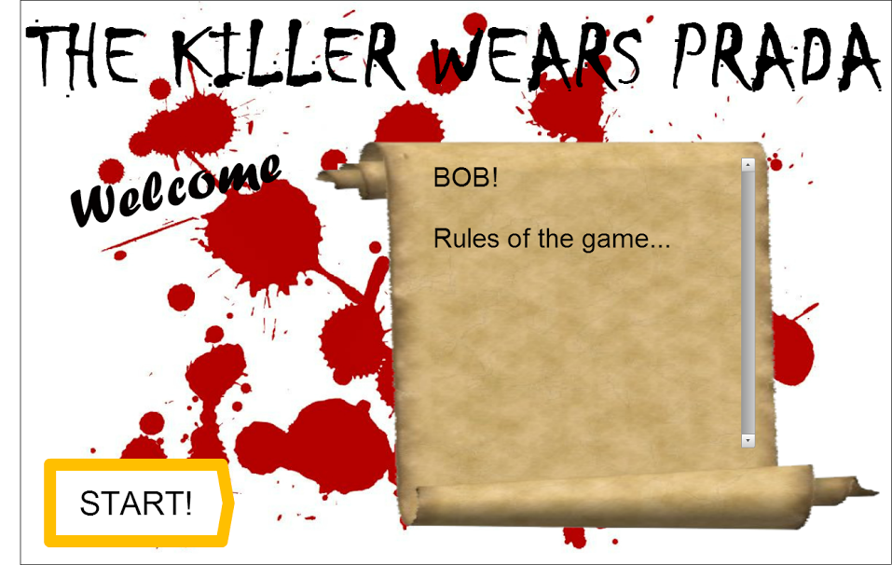

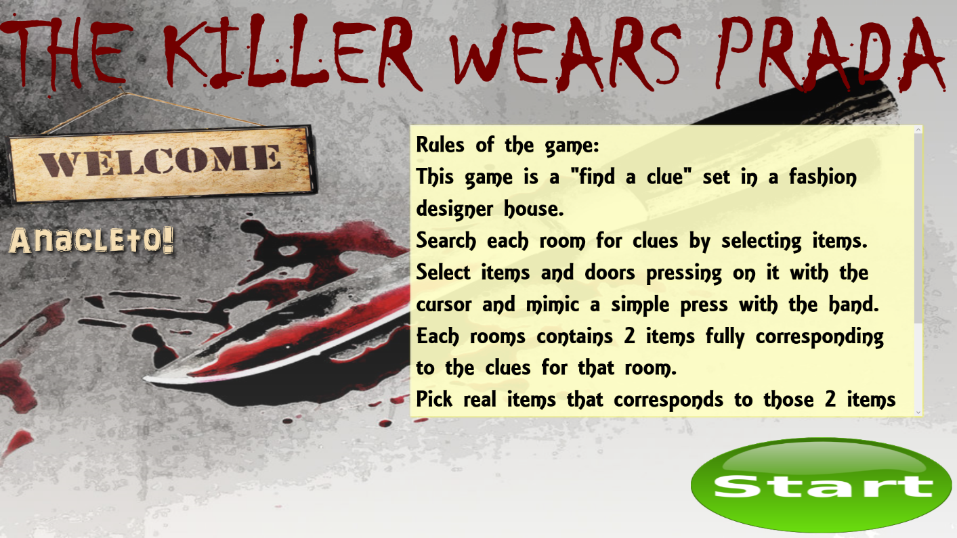

He decides to start and using the Kinect presses the Start button.

It goes to the first game screen, showing a hallway with some closed doors:

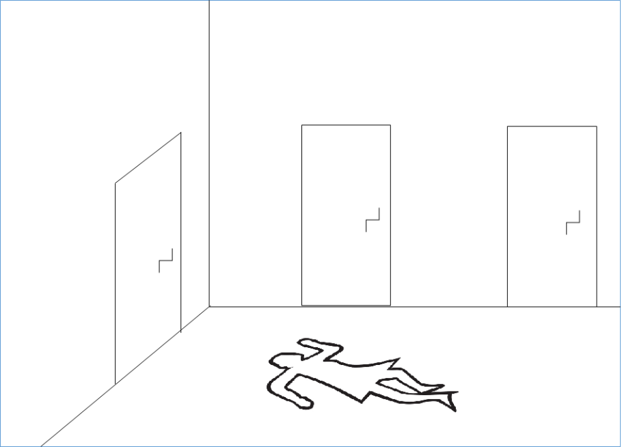

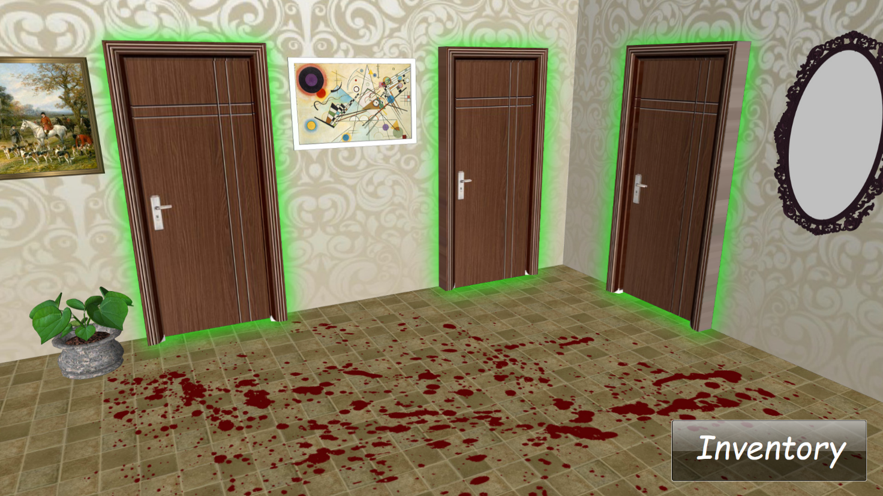

By making the right move, he opens the first door and the room is shown:

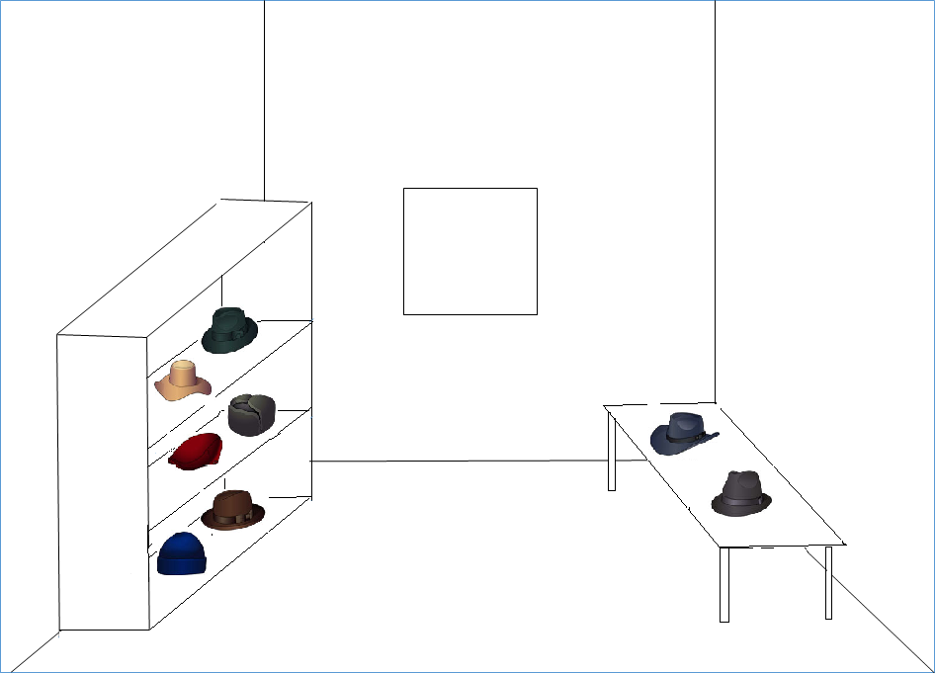

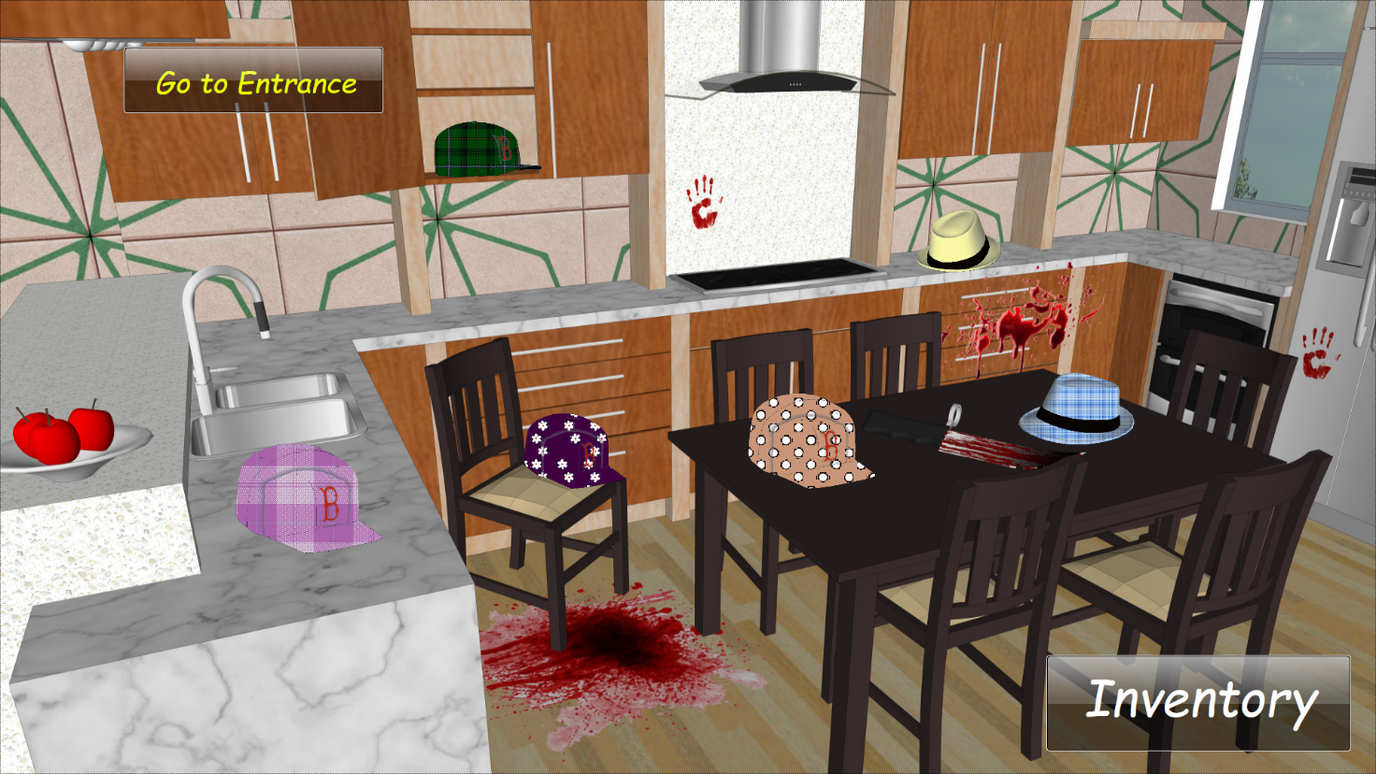

Navigating through the room using the Kinect, he discovers the first evidence. By pressing on it its photo and description appears, plus a clue:

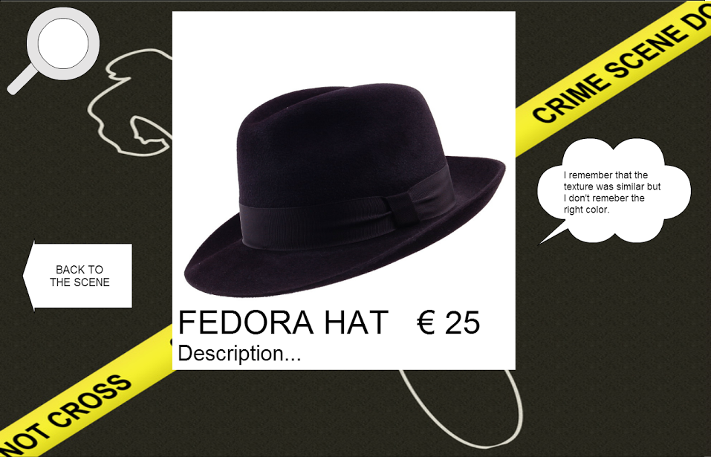

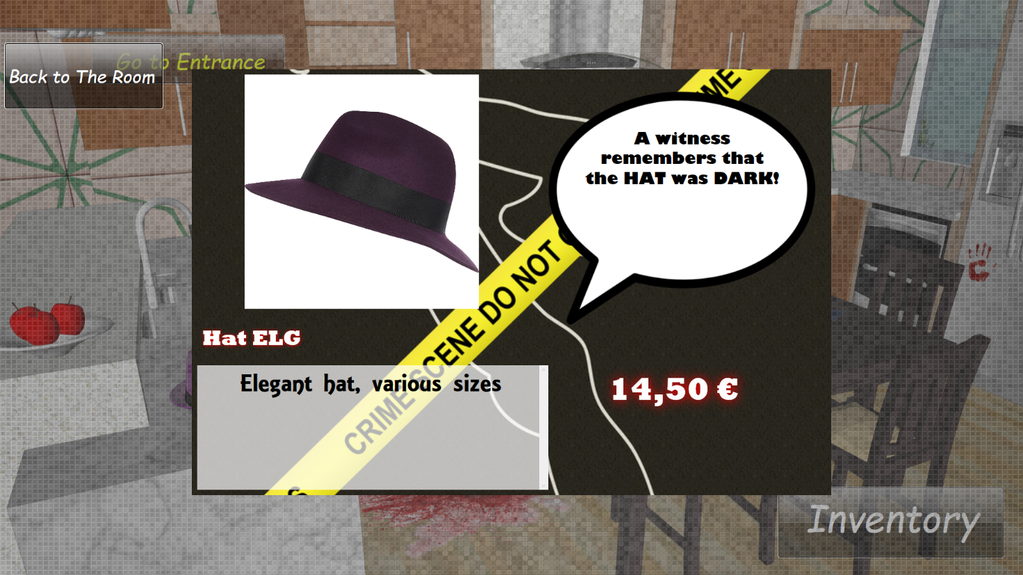

He decides to go looking for that object. The smart lights of that section will switch when he leaves the game stand.

## **Scenario 2: Parallel game**

Carla and her friend enter the shop looking for a dress. Unable to find it, they decide to try the new game offered by the shop.

After registering themselves, (scenario 4) they enter. The Kinect recognizes her QR-Code and the starting screen appears:

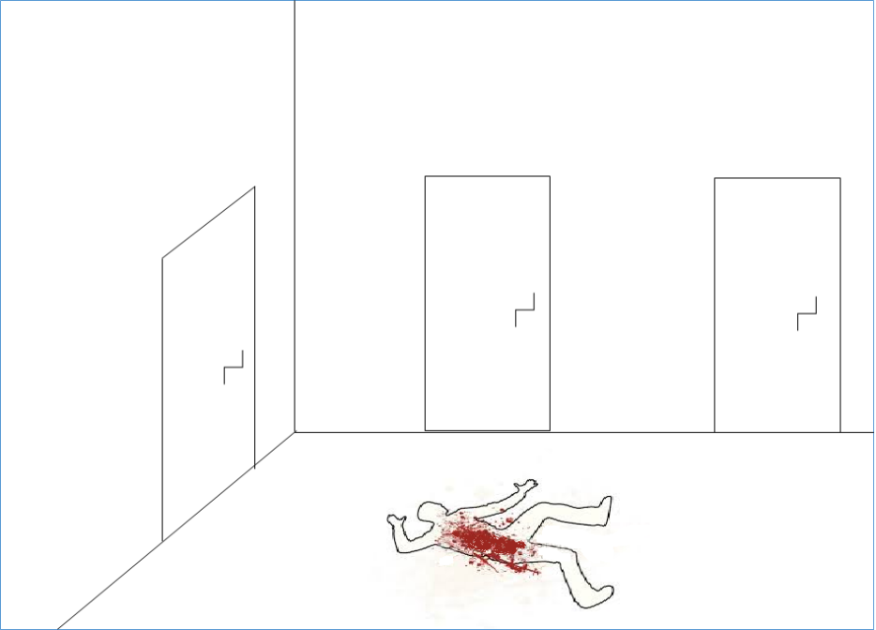



Then after the first screen, they enter the first room. They collect a couple of cloths and explore a couple of rooms.

Navigating through the last room using the Kinect, Carla discovers another evidence. By pressing on it a photo and description of the products appears, plus a clue:

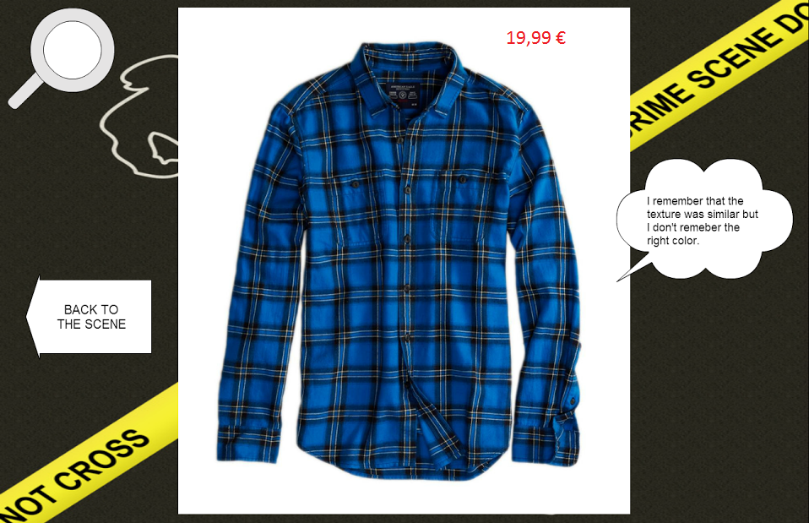

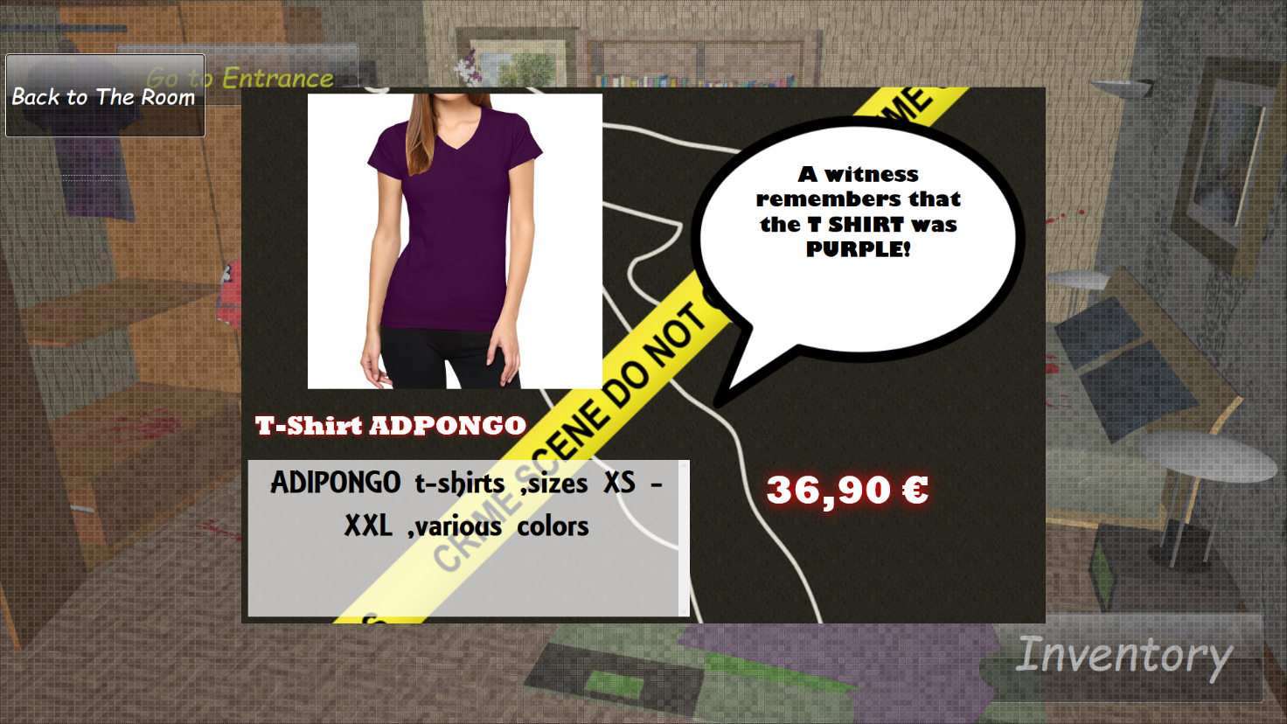

She decides to go looking for that object.

Carla returns since she forget what she was looking for because, during the search, she had found out a lovely skirt and wants to buy it. She returns to the Kinect, she lets the system recognize her QR-Code and then the room that she visited last appears. She accesses her inventory:

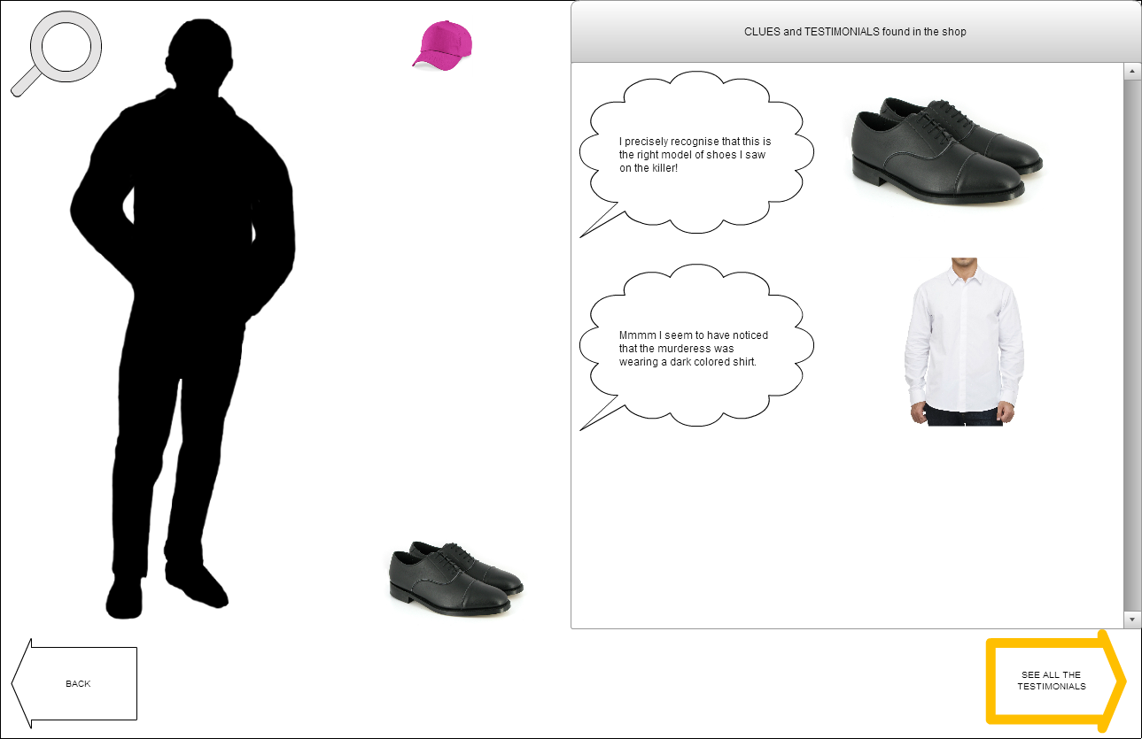

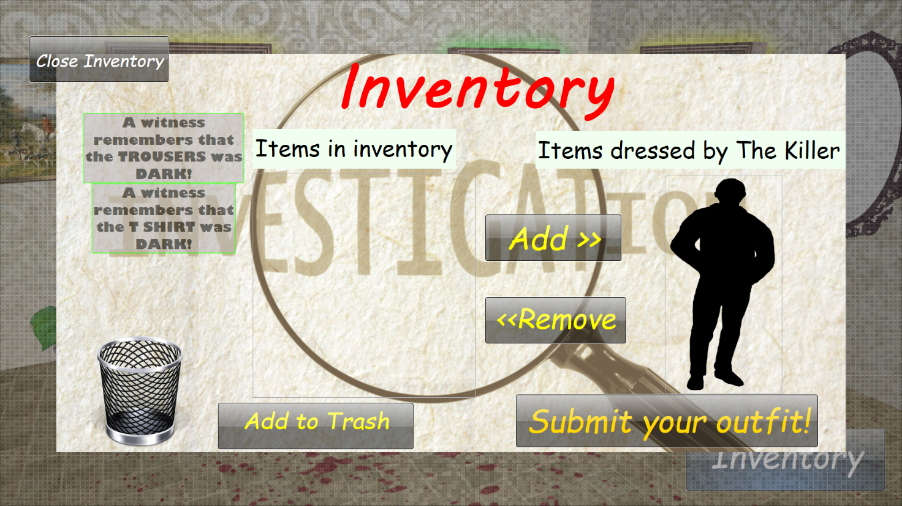

With a Kinect gesture she presses the button to see the testimonials and to remember the object she was looking for previously:

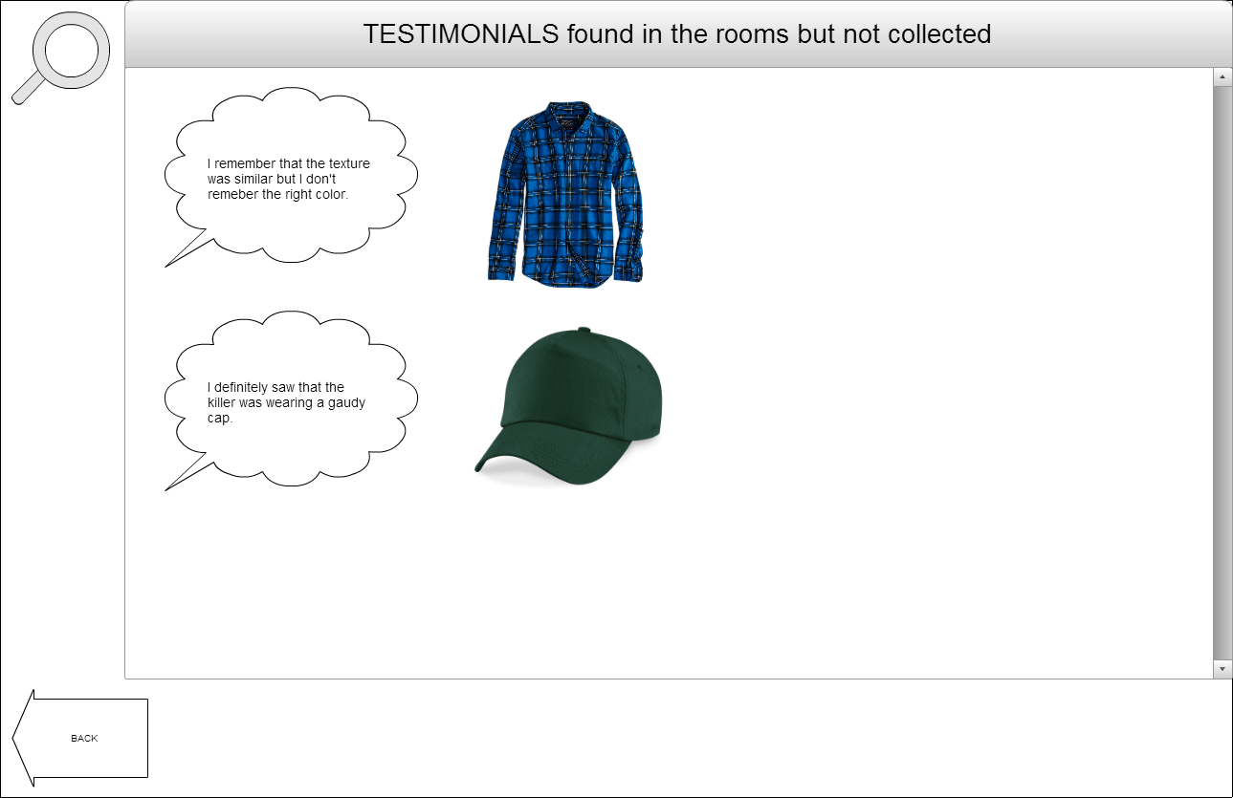

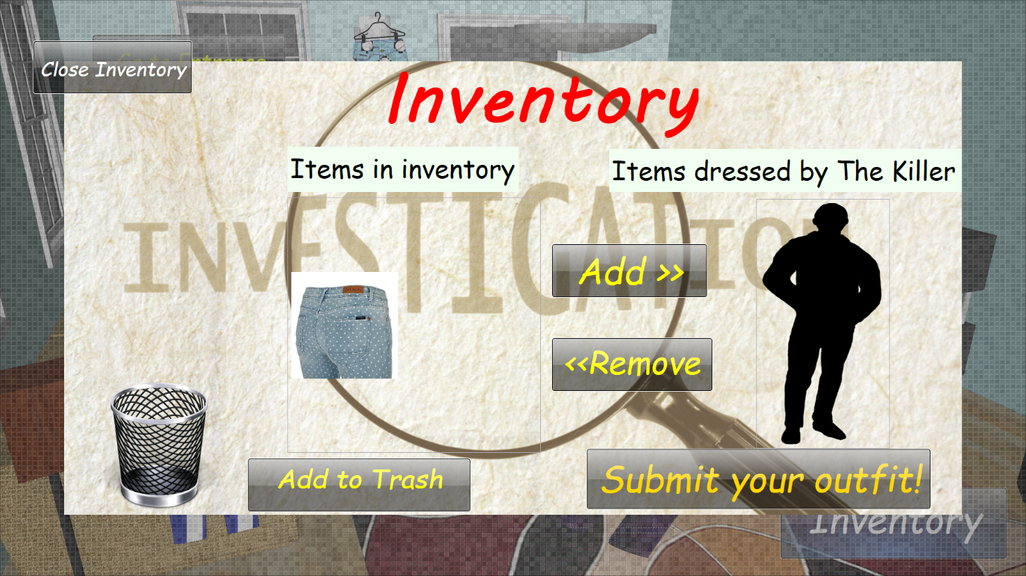

(we removed this screen and used it directly in the Inventory)

Now she can go looking for the object again.

**Scenario 3: Winning**

After finding the last possible clue, Anacleto returns to the Kinect.

He lets the system recognize his QR-Code and then the room that he visited last appears.

He checks if the cloth is right, and then adds it to its game inventory.

He is now able to propose a solution to the game, so he goes to the “identikit screen” and creates the killer outfit by dragging the right cloths from the clues and testimonials portion on the black silhouette:

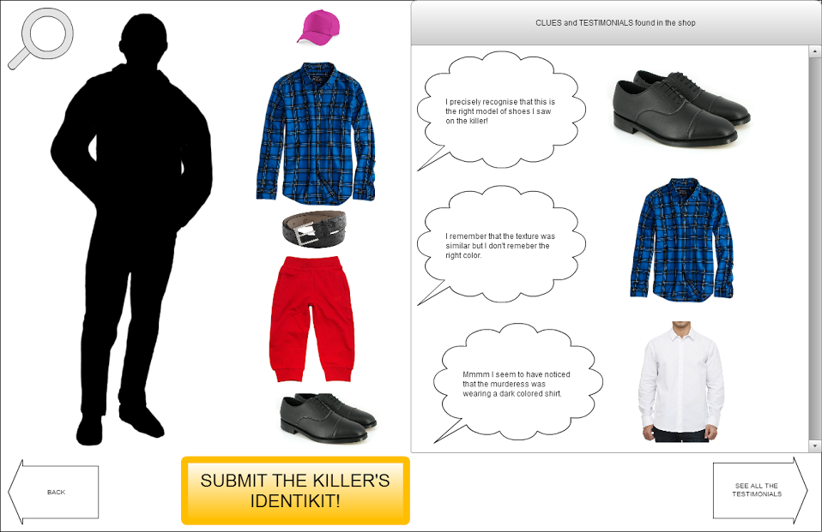

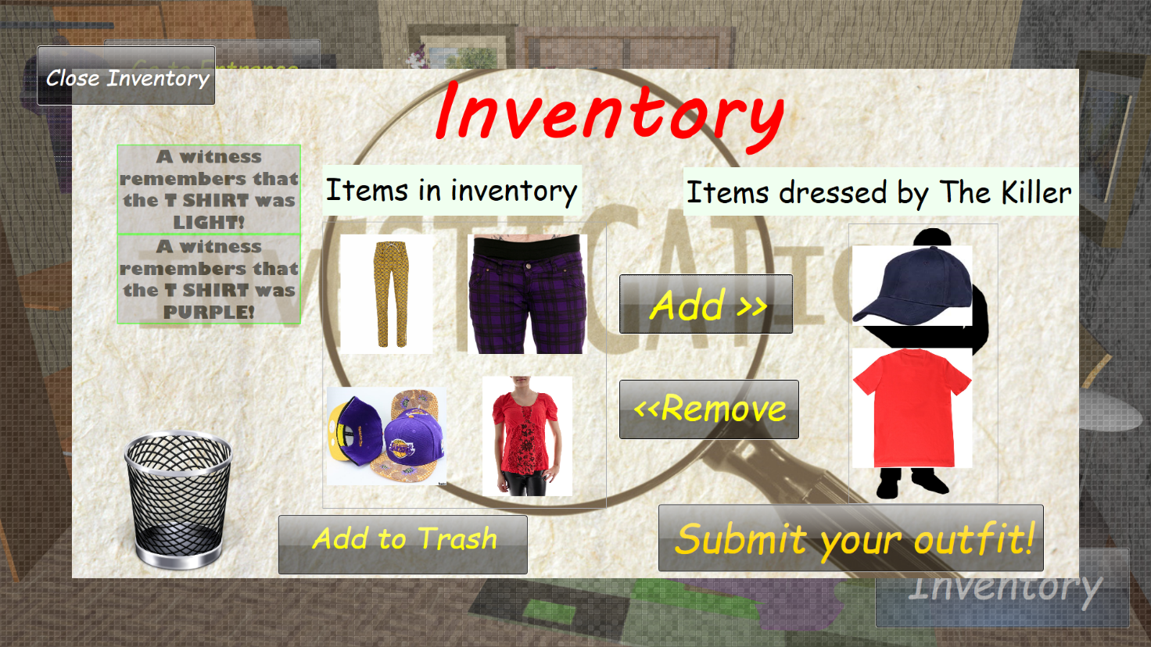

He then submits the solution and… it is correct! He gets the Victory screen.

Then its discount is printed, he can take a photo with that outfit and share it on Facebook:

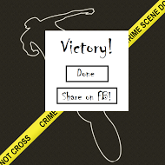

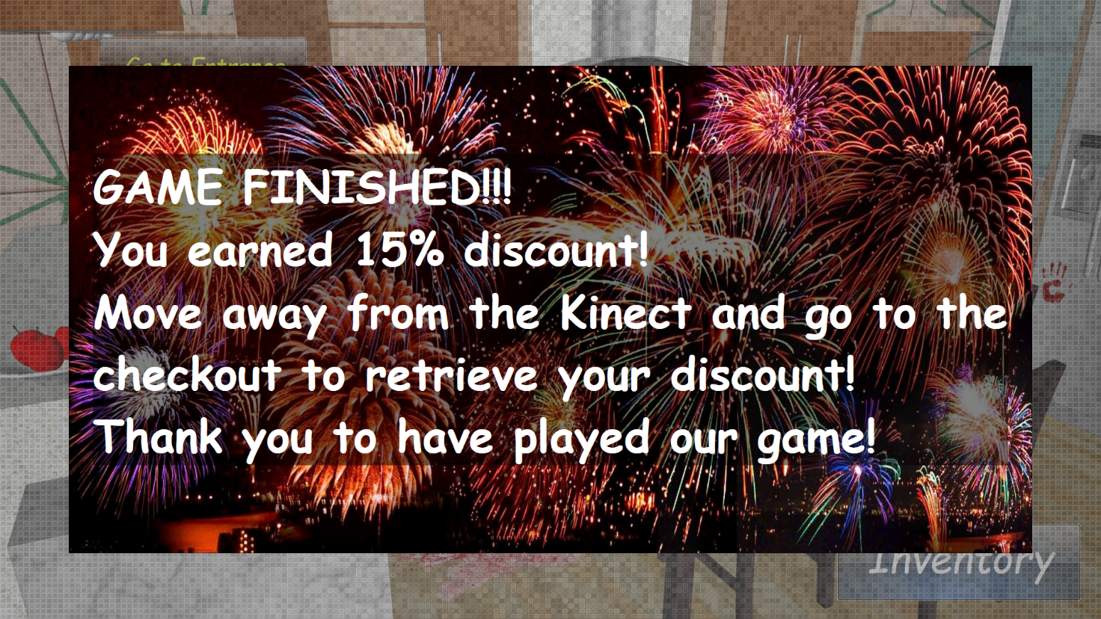

His wife has ended her purchasing at last. He now can use his discount.

## **Scenario 4: Registration**

Diana, an employee, inputs in the game system the players data (name, surname…) and prints out the QR-Code related to the user. The QR-Code allows the user to play the game and it is used to identify him/herself.

## **Differences between prototype and real solution**

In order to allow a better game playability to we relaxed some of the original rules.

Now each room always contains the same kind of items, which allows many simplifications when populating the rooms.

We added a Trash bin, which is reachable from the Inventory, where is possible to put items the player. It’s possible to empty the trash (removing all elements) or restore an element. Once an item is removed, to add it again to the Inventory the user had to take its Barcode in front of the Kinect again.

Clues are assigned randomly to each item, not according previous discovered clues. This because we want the user to look at each Item, since one of the needs to address is Item discovery.

The player no longer needs to be in the right room to add Items to his inventory, it is enough that the items he/she brings in front of the Kinect is one of the depicted ones in order to add it.

From the ending screen we removed the possibility to interact with Facebook.

# **Game Logics**

This section covers all the aspects related to game logic. Here we explain the Game concepts and rules; then the population procedures and finally we clarify some other aspect of the game.

## **Game concepts**

1. **Item**

The item is the in-game representation of a cloth present in the shop

1. **Item Kind**

The item kind represents the kind of cloth that the item represents (ex. Trousers, Shirt etc.). For our demo we used 3 Item kinds: Hat, Trousers and T-shirts.

1. **Clue**

The clue is a characteristic/property of the item. We defined 4 properties: Color, Gradiation, Shape and Texture.

* 1. Color

For the Demo we insert 8 colors: black, blue, brown, green, red, purple, yellow and white.

* 1. Gradiation

The gradiation represents the color gradiation of the item. It can be ‘light’ or ‘dark’.

* 1. Shape

The shape tells us if an item is long or short. Its meaning varies based on the kind of the item. As an example, if the item is a shirt it means long or short sleeves. A particular case regards ‘hat’ item kind. For those items ‘long’ means they are wide-brimmed hats (like Fedora) while ‘short’ means they are Caps.

* 1. Texture

The texture represents the texture of the cloth. We added 5 textures: flowers, pois, stripes, scottish and plain-color.

1. **Room**

The room contains Items of the same kind. For the Demo we created 3 rooms containing hats/caps, trousers and t-shirts.

1. **Inventory**

The inventory contains a list of all the clues already discovered and a collection of recognized Items (items whose Barcode had been recognized by the Kinect). From here it’s possible to discard unwanted items in the trash and to create an Identikit.

1. **Identikit**

The identikit is the reconstruction of the outfit of the killer.

## **Game rules and mechanics**

This game has fairly simple rules, which are the basic rules for a treasure hunt. Each item reveals a clue about the correct item, which is one of the items shown in the room. After collecting enough clues to identify the 2 candidates “right” items, the player has to collect the real clothes associated to them. He will be able to do so because each item, when selected, shows a photo of the real cloth plus some information about it. Once the cloths are collected, the player has to show their Barcodes to the Kinect, which will recognize them and add them to the Inventory. NOTICE that to add an item using the Barcode also the player’s QR-Code had to be visible. When all the 2 candidate “right” items had been added, a resolutive clue is shown. Whit this clue the player will be able to correctly recognize the right Item when she will have to create the Identikit. This process is repeated for every room. The Inventory is accessible at any time. From the Inventory items can be removed by putting them in the trash. When all the items and clues had been collected, the player has to access his inventory

## **Population**

All the possible combinations of Kind and properties made up more than 400 possible combinations. We decided that each room contains always the same kind of item, which reduces the number of combination to 140. This is still a big number so for this Demo we adopted some tricks to reduce the amount of possible combination and lower them to 75 per room.

In order to extract correct game items a semi-randomic population algorithm had been used. This algorithm is based on the fact that we start by randomly extracting the properties that the right item has to have.

So first we create the clues by randomly choosing 3 out of 4 possible clues. Two of this clues (called 1 and 2) are given directly for the items in the room and allows the user to identify the 2 “most correct” items, while the third one called 3) is the deciding one, which allows the user to choose the correct item. Then we extract from the DB the items, following this table:

|  |  |  |  |  |
| --- | --- | --- | --- | --- |
| Kind of Item | Clue 1 | Clue 2 | Clue 3 | Clue 4 |
| A | true | true | true | don’t care |
| B | true | true | false | don’t care |
| C | true | false | true | don’t care |
| D | true | false | false | don’t care |
| E | false | true | true | don’t care |
| F | false | false | false | don’t care |

A is the correct solution, which means that this item corresponds to all the clues we extracted. B is the second “more correct” item.

Once items had been chosen, each of them gets a sentence that states the clue (like “the correct item is RED et.) in a random way.

This procedure guarantees that the population of Items in each room changes for every new game while following the game rules.

# **Design and Graphical Choices**

This section explains the graphical choices we made during the Design phase in order to make the game experience more entertainable and user-friendly.

**Graphical choices**:

* In-game windows appearance
* Color-changing door light
* Button animation
* Gestures
* Popups

## **In-game windows appearance**

When the player selects an item from a room, the information regarding the cloth and the respective clue are shown in a screen: we investigate the best way to display these information and after having tried some implementations we decided upon the one shown in the below picture.

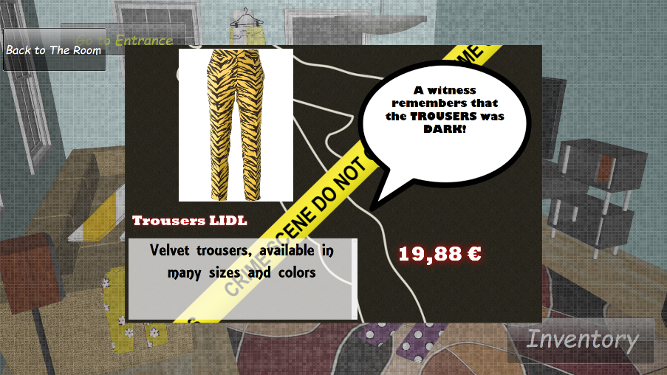

This windows appearance provides many advantages: the player does not lose the eye contact with the room she is investigating, so she does not fill lost. She knows that she is exactly where she was when she pressed the cloth button. At the same time the squared section outside the screen allow her to notice that she cannot interact with object in the room. She has to close this popup in order to continue the investigation.

The inventory and the trash windows are constructed in a similar way, in order to obtain the same effect on the player.

## **Buttons**

We make every clickable object reacting to the Kinect-hand over, in order to give the player a feedback in what she can explore in every room.

Cloth items react to the hand over by zooming

Simple buttons react by changing the background colour or light

We implement the Trash button in a particular way: it reacts to the hand-over by blinking only if it has some items inside. Moreover it changes its aspect when some item is trashed. Otherwise it is visible empty and not clickable.

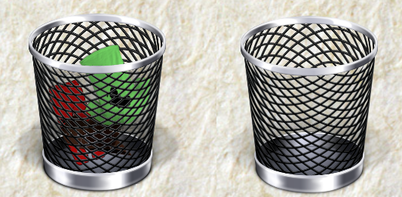

## **Position of the Buttons**

A way to help the player in not making wrong action is the arrangement of buttons in the window. By putting buttons far away as possible between them we prevent the user to press the wrong button and have to redo an action, thing that can be really annoying. That’s the reasoning that leads us to the actual placement of buttons in all the screen. Button are positioned and sized in order to be easily accessible and to avoid errors as much as possible.

## **Colour-changing door light**

In order to help the player in keeping track of the state of his investigations we added a coloured blinking effect around the contour of the doors in the Starting room.

The light blinking effect on the doors can be displayed in 3 different colour, according to the state of the investigation in the respective room:

1. **Green** indicates that in the room behind that door no clue was already discovered.
2. **Yellow** indicates that in in the room behind that door the player has just started to investigate by clicking on some items and has discovered their clues, but she has not yet discovered the last clue of the room, which means she had not yet brought all the Barcodes for the items inside.
3. **White** indicates that the investigation in that room has been completed, i.e. the last clue has been already discovered.

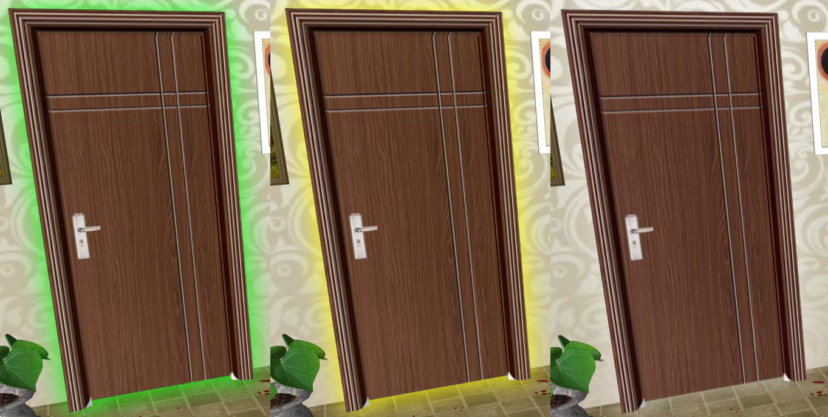

In this way we try to help the player in visualizing the state of his game and guide him to the next move

## **Gesture**

We decide to use the simplest gesture available in order not to annoy the user who is probably not so good at using the Kinect or in doing strange r complex gestures the right way. As stated before, making the user doing the perfect movement is not part of our goal; he has to enjoy the game experience in a quite comfortable way.

The only gesture the player has to do are:

* Push buttons
* Drag and scroll

## **Popup and animation**

We think that the best way to give the player some feedbacks during the game is through Popups appearing from the center of the screen or through animations.

**Popups**

Popups appears from the center of the screen, are displayed for 5 seconds and then automatically disappear. They are used to communicate to the player the result of his last action. As an example, when the player “passes” the item’s Barcode in front of the Kinect he will always receive a feedback when the Kinect has actually recognised it.

In the case of the Barcode recognition there are 3 different popups:

1. The item is present in the game of that player and so it is added to the inventory
2. The item is not part of the game, so we don’t make it be added to the user’s inventory
3. The item is present in the game and it is the second item found (i.e. added to the inventory) that fits the clues of a room: in this case the popup shown also contains the last clue of the respective room.

Popups are used also in inventory, to alert the user that he cannot dress an item on the killer if the villain already has a cloth of the same kind.

**Animations**

An animation is shown when the user adds an item while the focus of the game is still on the room in which that item was discovered: the cloth sketch is moved from its position to the button inventory. In this way the user can easily understand that the item has been added to the inventory.

They are implemented only for clothes in rooms.

## **Demo Scenario**

Now that the rules and the graphical Here we write a demo scenario that show in details the game mechanics scenario we used for the demo.

Andrea goes into the clothes shop and decides to try their new game. He enrolled in a specific desk and the employee gave him a QR-Code.

Andrea goes to the Kinect workspace and waits until the previous player leaves. Then Andrea steps forward and places itself on the sign in front of the Kinect. He waits until its QR is recognized and the starting screen appears.

After reading the rules Andrea press the Start button and the game commences. A Hall with 3 green-glowing doors is shown.

Andrea decides to visit the room behind the first door on the left. After pressing the door a []room filled with [] is shown.

Andrea selects the first Item, the …… . After pressing on it and a new screen appears.

This screen shows all the details about the real cloth, a photo and a clue which, combined with the others 2 that Andrea will discover during the game, allows to identify the correct Item for that room (or that kind, which is exactly the same since one room contains one and only one kind of item).

Andrea repeats the same procedure for all the items in the room, and the following 5 screen appears:

As already pointed out Andrea is able to collect only 2 clues for this item kind.

Andrea now decides to look at its inventory to see a recap of all the properties that a correct cloth has to satisfy. By pressing on the Inventory button the inventory screen appears

Now that Andrea knows which items he needs to look for, the player leaves the workstation and starts the searching.

After a while Andrea has collected 4 items ::::::::

The player takes them in front of the Kinect and shows their Barcode one at a time:

1 ------------------- giusto

Andrea returns to the hall and notices that now the light around the newly visited room is yellow

Andrea shows other Barcodes

2--------- non c’entra

3-------sbagliato

4------------2° giusto

After the recognition of the 2nd right item, the 3rd resolutive clue for the room is shown

Andrea leaves the room and returns to the Hall. The player notices that the door closing the room he just finished glows white.

The player then repeats the aforesaid procedures for every single room until he disclose all the resolutive clues.

Andrea now goes in the Inventory to create the Identikit of the killer.

The player notices that the item … doesn’t fit any clue and decided to discard it. He selected it and then presses the…button. The item disappears from inventory.

Andrea reads the clues and recognizes the 3 correct Items. The plyer selects them one by one and pressing ADD.. the items are added to the Identikit.

Then the

# 

# **Implementation**

This sections covers all the implementation aspects of the project. Since no specific Hardware is needed, this section is only about software implementation.

The project was implemented using Microsoft Visual Studio 2015, and so we used C++ language.

For this project a MVVM (Model-View-View Model) pattern had been used. This means that the project is highly modular, easily expandable and adaptable.

This chapter only covers View Model and Model, while View is detailed in the following chapter (Interface).

To better clarify components structure and their interactions, UML schemas had been provided.

This is meant to be a guide to the main concepts involved in the implementation. To understand how the elements we will explain in the following paragraphs are implemented in code, we suggest to look directly at the commented code available at <https://github.com/Amebus/KillersWearsPrada>.

## **Database**

Database are a critical aspect of modern applications, and this one is no exception. The main difficulty in was to create a DB structure that was able to interface with an already-existing consumer DB without having to change the whole structure of the project.

In order to accomplish this we adopted the following DB schema:

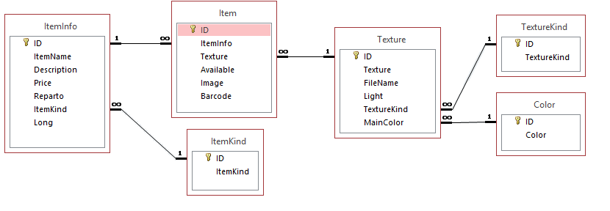

ItemInfo represent the hypothetical DB provided by the shop owner, which contains general information on the real cloth.

ItemKind contains the kind of outfit of an item (ex. Trousers).

Item is the core table, the one that works as a bridge between the graphical representation and the real data of the items. Here the item’s info are connected to their textures (graphical representations).

Texture contains the information on the graphical aspects of the item. Combined with Color and TextureKind it states the main color, the texture and the color gradiation of the item.

Our “demo” DB contains 302 items whose content are real word ones (each of their photo is a real one that had been taken from the Internet).

This separation between graphical and general info allows us to manage the consumer information (stored in ItemInfo) apart from the graphical information we used in for the in-game representation of the items. This also means that with an easy (even if not short) work we should be able to adopt this structure for every kind of DB our consumer provides us. Notice that a DB adaptation may not be necessary thanks to this interface.

## **Database interface**

The Database interface allows the communication between the real DB and the program. This allows the program to see the DB as a BlackBox, which allows us to ignore the DB characteristics (language, structure) with respect to the program. Moreover this contributes in the creation of a modular structure of the project, which is unbounded from the DB structure that is used. It will only suffice to change the interface in order to adopt the program to different. In addition to that, we can also address the issue of safe DB queries (better discussed in Risk Analysis paragraph) since we do not allow direct connection between DB and program.

## **Classes**

Classes creates the model structure of the game. Classes represents the objects of the game. The main classes of our projects are:

1. **Game**

It is a container class that represent the actual state of the game. This class contains all the objects from other classes is serializable and it’s used to save the state of the game when the player switches.

1. **AbstracItem**

Contains the graphical properties that an object had to have in order to be retrieved from the DB, which means Color, Gradiation, Shape, Texture and ItemKind. It is used in the population phase.

1. **Item**

This class is the software representation of the item in the game. It contains all the information about the item retrieved from the DB (its description, price, and data). It extends an AbstracItem, so contains also the graphical properties. It also contains the Clue property

1. **Item Graphical Properties**

For each of the aforesaid graphical properties, it contains the effective value of the property.

1. **Player**

The player class represents the player in the game. It’s related to the player table in the DB. It contains the player’s Username, QR-Code and score.

1. **Room**

This class is the implementation of the game Room. It contains all the items and the last, and resolutive, clue.

1. **Solution**

This class contains object of AbstracItem kind that represents the graphical properties of the correct Items.

**Implementation of other Game Concepts**

1. **Trash**

The concept of Trash is implemented with a simple Boolean variable (IsTrashed) assigned to an Item object. Each time the Trash window is opened, a loop loads all the Items with the IsTrashed attribute set at true.

1. **Inventory**

The concept of Inventory is implemented with a simple Boolean variable (IsInInventory) assigned to an Item object. Each time the Inventory window is opened, a loop loads all the Items with the IsInInventory attribute set at true.

1. **Clue**

The clue concept exists as property contained in the Item object. As explained in the rules, every time a player clicks on an Item, the rule related to the item is retrieved from the related Item object by asking the clue property value.

The clue is translate as a string and it’s corrected with respect to the ItemKind.

## **Helpers**

Helpers are classes that creates an interface between game and external API. Helpers works like libraries that provides methods to use. In our project we have the following helpers:

1. **DB Helper (Database interface)**

This helper manages all the queries that had to be executed on the DB. The

1. **QRreader Helper**

Acts as an interface with methods of ZXing, which are used to recognize BarCodes and QR-Codes. We apply ZXing methods to pictures taken from the Kinect.

1. **Resource Helper**

It manages the App.xaml resources.

1. **Sketch Helper**

It’s static class that is used for the graphical interface. It uses methods provided by Magik.Net. It creates sketches of the Items that represent them in the game.

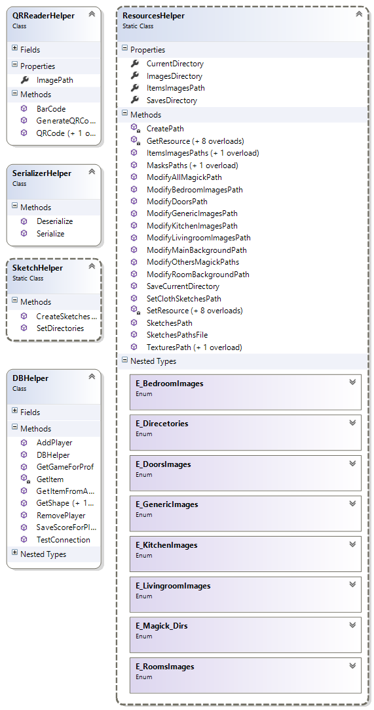

## **Controllers**

Controllers manages the game flow.

1. **PlayerChecker**

It checks who the player in front of the Kinect is. It’s used to manage the multiplayer features.

1. **KinectInterrogator**

Takes the images generated by the Kinect and passes them to the Bar- and QR-Code readers already defined. It also check’s the BodyCount (how many shapes are in front of the Kinect).

1. **GameController**

It creates the game and it manages the player context switch.

1. **BarCodeRecognized**

It’s a Dummy class that contains the event “Barcode recognized” which is triggered by KinectInterrogator and received by GameController

The game flow proceeds as follows:

KinectInterrogator takes the images from the Kinect. Then it send them to PlayerChecker whose job is to understand who is standing in front of the Kinect. If the shape corresponds to the player that is currently playing everything is fine, otherwise it sends a “player changed” notification of to the GameController. When GameController receives a “player changed” notification it saves the current context and notifies to the graphical component to unload the old game and wait for a new game to load.

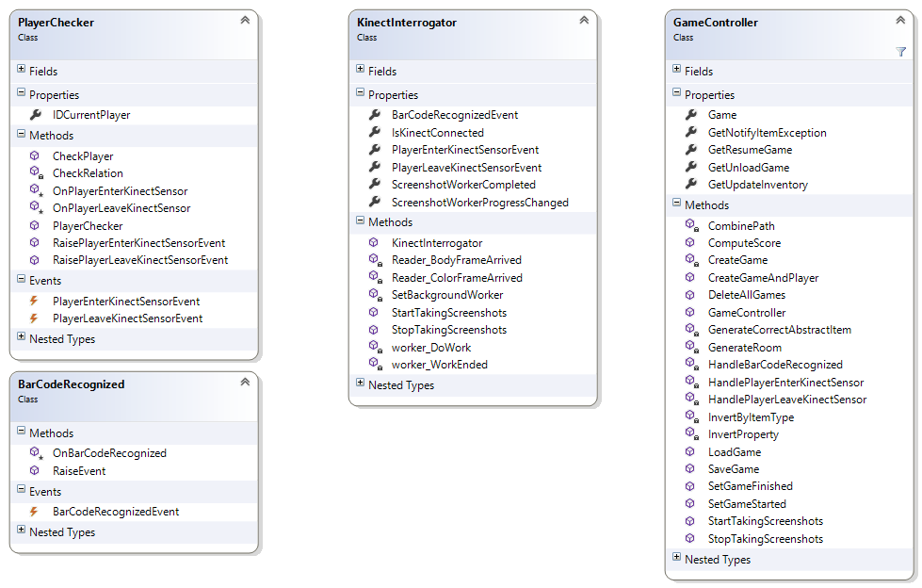

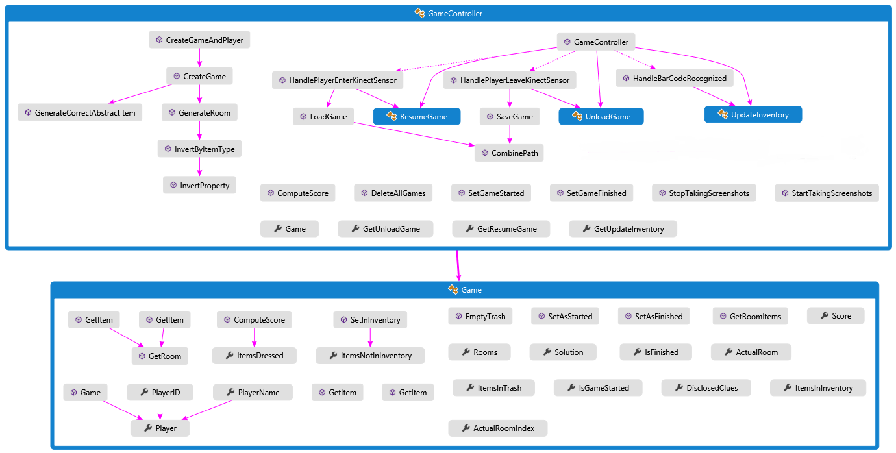

Game controller -> model interactions

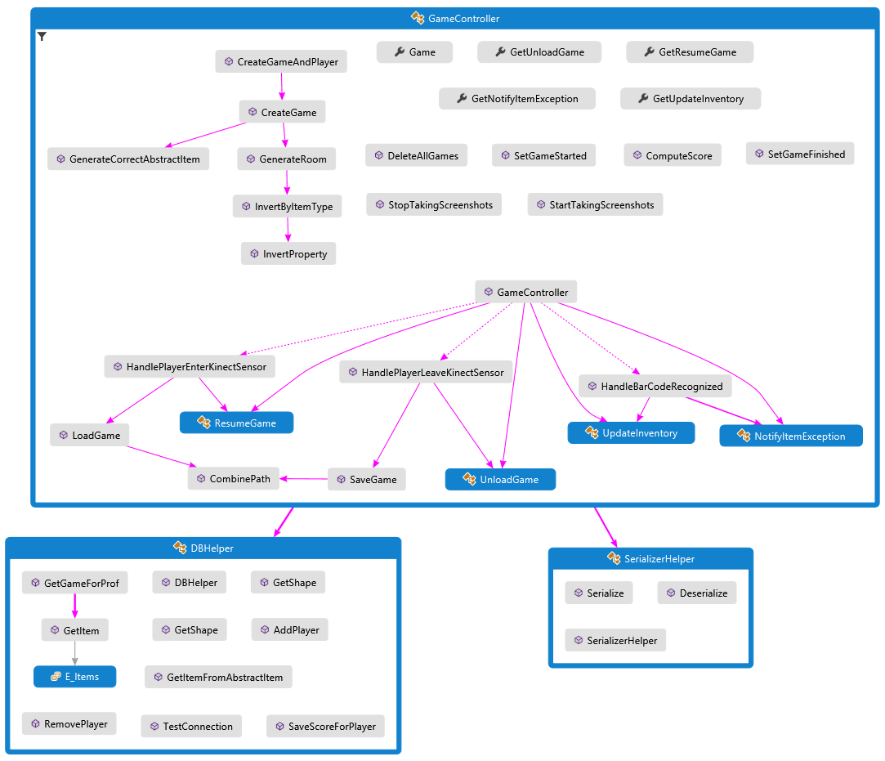

Game controller -> helper interactions

# **Graphical Interface**

This paragraph describes how the elements presented in the Design and Graphical Choices had been implemented.

## **UserControls**

All the graphics elements are organized in UserControls. The main UserControls are StartRoom and Room.

StartRoom is the entrance room, where there are the doors of the rooms in which the player has to go in order to start investigating.

Room contains all the rooms of the stylist’s home: there are 3 Canvas (one for Livingroom, one for kitchen and one for bedroom) each one containing its respective buttons inside, and their visibility change according to the room in which the player is going to.

They are generated by the MainWindow.

The file App.xaml contains all the graphical styles of buttons and windows, the messages and the text fonts.

Items Objects are implemented as buttons when shown in the graphical interface. This allows them to be clickable, to show their animations and helps in managing them.

STORYBOARD E VISUALSTATE3

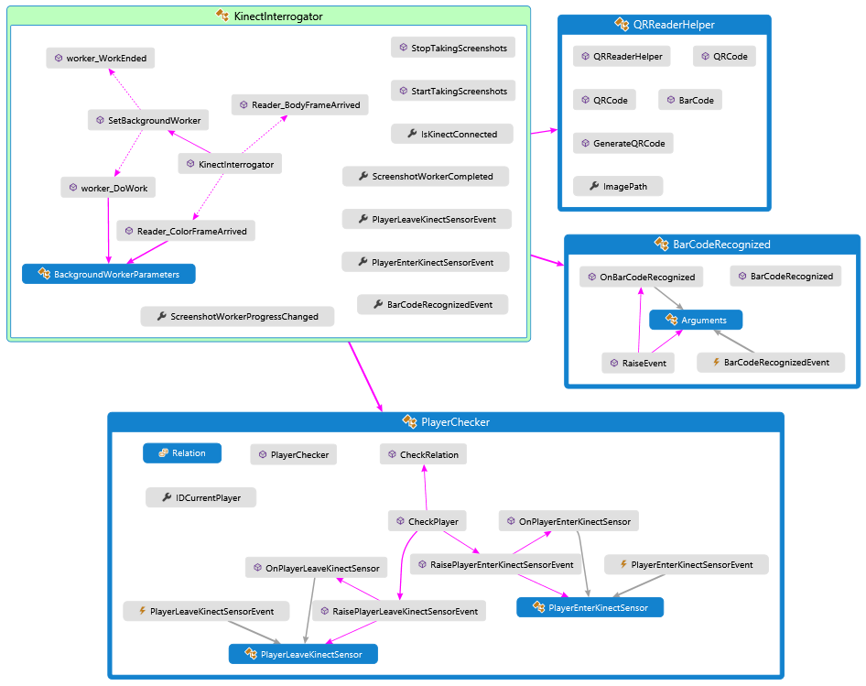

Kinect interactions

**Feasibility study**

**Technical Analysis**

This section explains the technologies adopted for the project and gives an idea of the required time

### **Hardware**

In order to realize the project the following hardware components are needed:

1. Kinect v2 sensor ,which includes a power hub and USB cabling
2. Desktop computer with the following characteristics:
   1. Operative system:
      1. Windows 8 (x64)
      2. Windows 8.1 (x64)
      3. Windows 8 Embedded Standard (x64)
      4. Windows 8.1 Embedded Standard (x64)
   2. 64 bit (x64) processor
   3. 4 GB Memory (or more)
   4. I7 3.1 GHz (or higher)
   5. Built-in USB 3.0 host controller
   6. DX11 capable graphics adapter
   7. At least 1 TB HD
3. A full HD widescreen of at least 50’’

### **Workstation constraint**

In order to make the game perform at its best, some hardware and workstation constraint had to be followed:

1. Put the Kinect at 1.00 m from the users in order to recognize the QR-Codes.
2. The Kinect had to be placed at 1.10 m of height.
3. To read the Barcode put it at 45-50 cm from the Kinect.

The game had been configured to work on a 16:9, full HD screen (1920x1080).

### **Software**

In order to be able to execute the project the following softwares are need:

1. One of the following Bar- and QR- Code readers
   1. ClearImage
   2. BarcodeLib
   3. ZXing
2. Kinect drivers

### **Database**

The project extract its data from a database

It can extract data from an already existing DB (the one used by the shop) with small adaptation or a fully new database can be created.

The project can be adapted for each DBMS software which is already present

## **Timetable**

We can say that we were able to respect all the deadlines we put in our schedule since we just get a 5 day delay on the final project phase which shifted all the project. At the end we were able to recover part of the delay and ended with only 4 days of delay at the beginning of February.

**Business Analysis**

This section analyses the project on the business point of view, so it concerns costs and estimated profits

### **Profits**

**Monetary profits**

After the installation of a system much simpler and less entertaining than the one here proposed a famous clothes shopping brand increases its selling by just less than 10% and the number of consumers augmented considerably.

We estimate an increase in selling of more than 10%

**Brand profits**

Installing and allowing the consumers to use a new technological entertainment system will also increase the popularity of the brand and of the shop

The more popular the shop is, the more people will come to visit it

**Costs**

1. Technology
   1. Hardware

|  |  |
| --- | --- |
| Kinect v2 | 150,00 € |
| Desktop PC | 500,00 € |
| Widescreen | 800,00 € |
| TOTAL | 1450,00 € |

* 1. Software

|  |  |
| --- | --- |
| ClearImage Licence | 800$ = 750€ |
| BarcodeLib Licence | 1599,00$ = 1500 € (unlimited) |
| ZXing License | Price to discuss with developers |
| Kinect drivers | Free |

Usually a shop has its own methods or licences to read BarCode, so the license can already be present. Only an adaptation process is needed

* 1. Database

The costs for the Database varies a lot.

If the DB is already existing the adaptation costs will depend on the original structure of the shop DB, so had to be discussed case by case.

If it had to be created ex-novo the price depends on which technology the client wants to adopt

1. Development works

This aspect covers the cost which concerns our own work and are relative to the times listed in the previous Gantt schema. Our request is 4500 €

1. Installation, configuration and maintenance

Our system is easy to set up and configure on the Hardware aspect, while it can take more effort in the DB aspect, since previous systems had to be integrated.

Configuration prices varies based on the complexity of the work required to personalize and adapt the system to the client needs; an average can be 600 €

The software is easy to maintain and update and the cost of it will be 200€/year

**TOTAL COSTS:** 7000 € +/- 10 % + IVA (VAT)

**TOTAL BENEFITS**: at least 10% augment of selling, augmented brand popularity

**NOTE: ricordarsi il discorso di TIM e delle applicazioni per la navigazione in negozio per invogliare gli utenti ad andare in un negozio fisico**

**Risk Analysis**

This sections explains which risks are take into account and which strategies had been adopted to avoid them

|  |  |  |  |
| --- | --- | --- | --- |
| RISK | RELEVANCE | PROBABILITY | COUNTERMUASURES |
| Data loss | Medium | Very low | No direct connection between DB and game - Secure DB queries |
| No item discovery | High | Low | Rules on item population |
| Repetitive Game | Low | Low | Randomization in the game |
| Difficult scaling | Medium | Average | Augment HW requirements |

The system is meant to be easy to use and intuitive. This because the game interaction through the Kinect sensor are similar to actions in real world.

The main risk lays in the configuration of the system in order to be adapted to previous solutions or to be personalized on client requests. This operation can be costly and can cause an augment of the price that can exceed the quote.

# **Conclusion**

## **Main issues**

Even if the implementation of the project didn’t procced smoothly, we were able to address all the little problems that as usually appeared during the implementation phase with simple tricks that we already discussed before. The only real issue that we encountered was the image QR and Barcode recognition via Kinect. This caused a lot of trouble and delay and was partially solved with the application of some workstation constraint (listed in the next chapter).

To totally solve the recognition issue it’s enough to switch from a free recognition software to a licensed one (we give a full list in the Technical Analysis- Software paragraph). We did so with a time-limited trial copy and all the issues disappeared.

Another issue we solved was the elimination of game files after the end of a player. The unload function wasn’t able to eliminate the temporary files and after some games the memory was full and the game crashed. We solved the problem forcing the elimination via an ad-hoc function and the problem disappeared.

An issue we were not able to address was the introduction of the drag-and-drop functionality in the game. While it works while using the mouse in the test phase, we were not able to find a way to let it work with the Kinect but, since it affect in a minimal way the gameplay, we preferred to focus on more relevant issues.

**Further Works**

This project can be optimized and expanded, and we already find out some ideas for a future upgrade.

First in our to-do list would be the implementation of the interaction between game and social networks, in the specific Facebook. This surely suites the need we elicited at the beginning of this document, since giving the user the possibility to interact via a social network (maybe also allowing a log-in via Facebook) makes the game more entertaining. Moreover, and more interestingly, it enlarges the number of people that are reached by the news about the new game installed in the shop. The more people knows about that, the more people will come to the shop.

Then follows the enrichment of clothes kinds (ItemKind) including skirts, shirts, socks and shoes. This means also augmenting the number of rooms and enlarging the DB.

The final improvement would be the implementation of the drag-and drop functionality.

**Why Choose US**

We offer a product which is simple and easily adaptable.

It’s simple under any aspect: easy to use, easy to play, has a simple and intuitive interface and it’s easy to configure.

Its easiness in configuration leads to its adaptability.

It’s adaptable because, as stated before, can be used on every existing DB and it’s also context adaptable.

We used a Fashion context because this was the assignment, but the game can be played and used in many different contexts. We can change shop nature (from fashion to toys, to hardware, to grocery) or even change the context from a shop to a waiting room to make the waiting less boring, to a kid’s space in a restaurant, to a museum to make the visit more funny and entertaining and so on.

This is possible due the modular structure we used in the development phase. The structure also easies the maintenance and the expansion of the project.

All this factors made our project like a Swiss Army Knife: you bought just one instrument that can be adapted in order to solve many different issues.